**Vocabulary**

*Convective momentum transport:* momentum transferred by bulk fluid motion proportional to fluid density

*Kinematic viscosity:* viscosity divided by density of a fluid

*Laminar*: orderly type of flow (i.e. when syrup is poured)

*Molecular momentum transport:* momentum transferred through fluid by viscous action

*Newton’s law of viscosity*: shearing force per unit area is proportional to the negative of the velocity gradient

*Newtonian fluid:* fluids with molecular weight less than 5000

*non-Newtonian fluid:* complex fluids, polymeric liquids, suspensions, pastes, slurries, etc.

*Turbulent:* irregular, chaotic flow (i.e. high-speed mixer)

*Viscosity:* the physical property that characterizes the resistance to flow

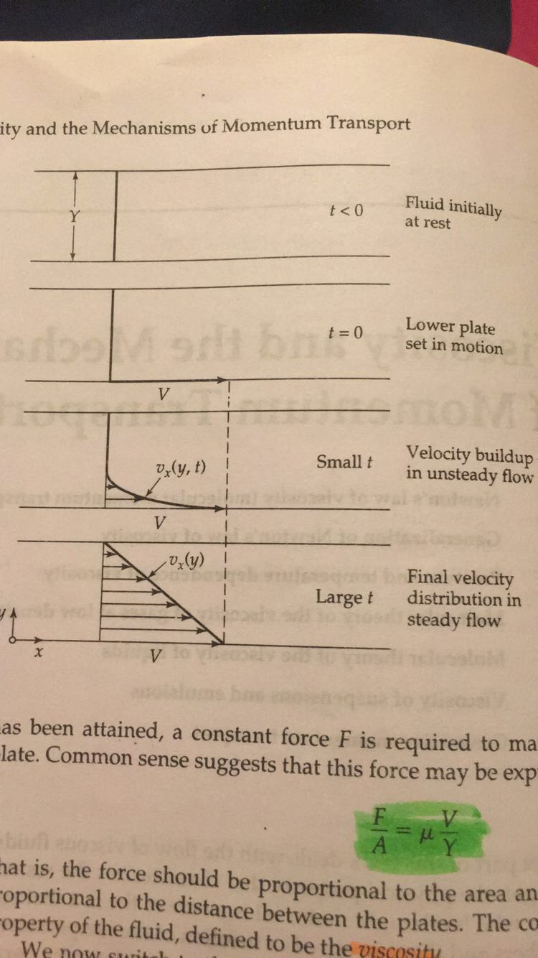

Once final velocity distribution has been attained, a constant force *F* is required to maintain motion of the lower plate.

*F/A = μV/Y*

*F/A = τyx*

*V/Y = -dvx/dy*

*τyx = -μdvx/dy*

Newton’s Law of Viscosity

* Not actually a law
* True for Newtonian fluids
* Momentum goes “downhill” from high velocity to low velocity (like sled from high elevation to low elevation)
  + Τyx = flux of x-momentum in +y-direction
* Velocity gradient is driving force for momentum transport
* Units:
  + μ = -τyx(dvx/dy)-1 [=] Pa * [(m/s)(m-1)]-1 = Pa * s

For gases at low density, viscosity increases with increasing temperature.

For liquids, viscosity usually decreases with increasing temperature.